HOW TO ADD RECORDS

Step 1:
Click the NEW Button
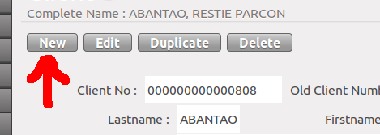
Step 2:
Fill all necessary data.
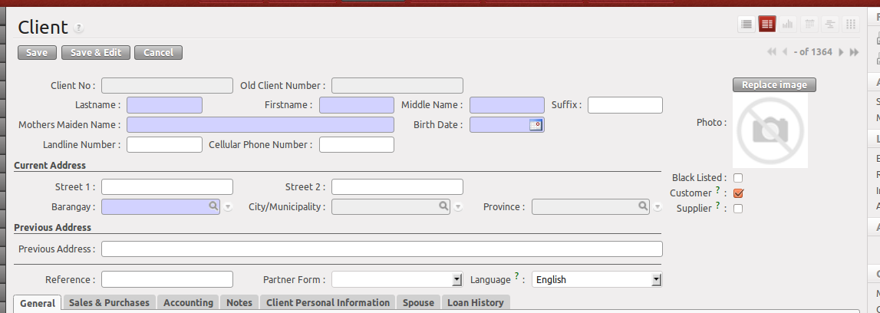

Gray Colored Textboxes → Cannot be edited. Either this will be supplied by the system or you are not allowed to input data for it.

Blue Colored Textboxes → Required fields. You are obliged to input data.

White Colored Textboxes → Fill this textboxes when necessary.

Fields with magnifying glass → This means that this field has a pop-up where you need to select one record.

HOW TO EDIT RECORDS

Step 1:
Click the EDIT button from the FORM View.
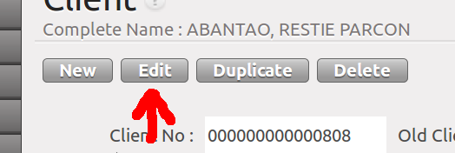
or click the EDIT icon (pencil) from the TREE View.
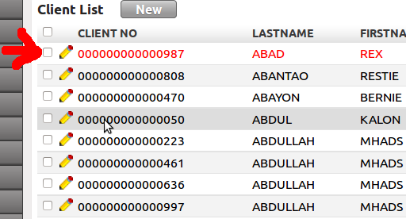
Step 2:
Edit the values of the fields.

Same with Add:

Gray Colored Textboxes → Cannot be edited. Either this will be supplied by the system or you are not allowed to input data for it.

Blue Colored Textboxes → Required fields. You are obliged to input data.

White Colored Textboxes → Fill this textboxes when necessary.

HOW TO SAVE THE CURRENT RECORD

Option 1:
Click the SAVE Button,
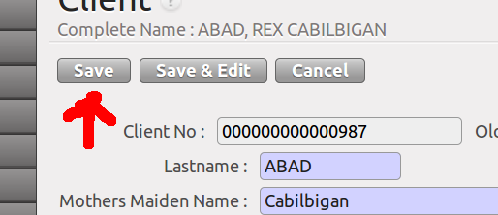
to commit the changes to the database.

Option 2:
Click the SAVE & EDIT Button,
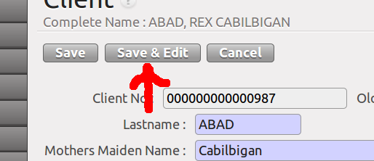
to commit the changes and continue editing.

This is useful specially for lengthy encoding like Client Information.

Warning Message:
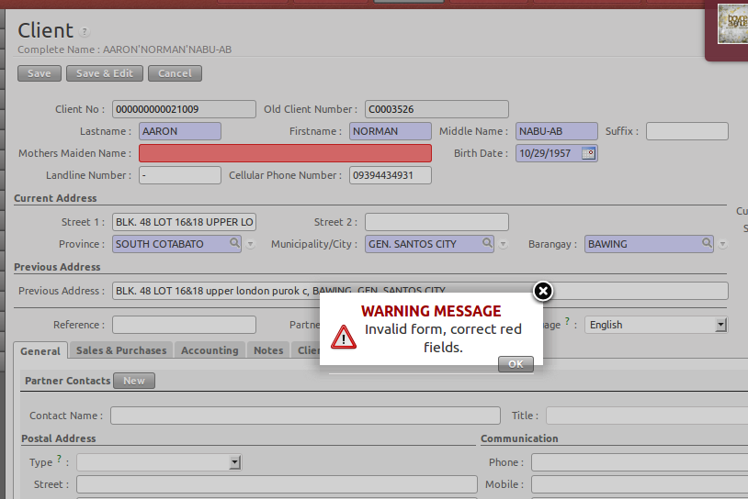
When required fields (blue-colored textboxes) are not filled-in, the warning message below will appear.

